Task 1: Introduction to Cloud Computing:
1. Sign up for a free AWS or Azure account and log in to the Management Console. Take a screenshot of your dashboard showing your name or email in the top bar.
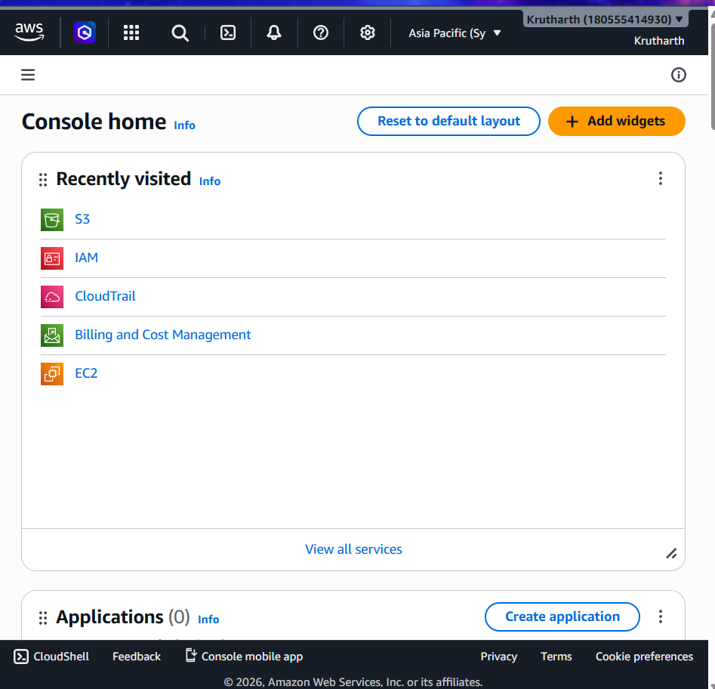

2. In the AWS or Azure Management Console, locate and list 5 key services (such as Compute, Storage, Database, Networking, Analytics). For each, write one line describing what it does and name one real app (like Instagram, Zomato, Flipkart) that could use it.
Category | AWS Service | What it Does | Example Application
Compute | EC2 | Runs virtual servers in the cloud to host applications. | Instagram uses cloud servers to run its application.
Storage | S3 | Stores files, images, videos, and backups securely. | Flipkart stores product images and customer data.
Database | RDS | Provides managed relational databases like MySQL and PostgreSQL. | Zomato stores restaurant and customer information.
Networking | VPC | Creates a secure private network for cloud resources. | Netflix uses private networking to secure its cloud infrastructure.
Analytics | Athena | Analyzes large amounts of data stored in S3 using SQL. | Amazon analyzes customer purchase data for recommendations.
3. Use the search bar in your AWS or Azure Console to find the S3 (AWS) or Blob Storage (Azure) service. Write down the steps you took to locate it and describe in 2-3 lines how a music app like Spotify could use this service to store user-uploaded files.
Ans: Steps to locate the service:
- Sign in to the AWS Management Console.
- At the top of the page, click on the Search bar.
- Type S3 in the search box.
- Select Amazon S3 from the search results.
- The Amazon S3 dashboard will open, where you can create and manage storage buckets.
- How Spotify uses the S3 bucket
Spotify could use Amazon S3 to securely store user-uploaded files such as profile pictures, podcast cover images, and playlist artwork. S3 provides highly durable and scalable cloud storage, making it easy to store and retrieve media files quickly from anywhere in the world.
4. Pick one key characteristic of cloud computing (on-demand self-service, broad network access, resource pooling, rapid elasticity, or measured service) and explain, in your own words, how it benefits users of a popular app you use daily (e.g., Paytm, BookMyShow, IRCTC).
Ans: Rapid elasticity means that cloud resources can automatically increase or decrease based on the number of users. This allows an application to handle sudden spikes in traffic without slowing down or crashing.
IRCTC experiences a huge increase in users during Tatkal ticket booking hours. By using rapid elasticity in the cloud, it can automatically add more servers to manage the heavy traffic and reduce them when demand decreases. This helps users book tickets more smoothly and improves the overall experience.

